Course Preview: Microeconomic Theory and Public Policy
Answers
This course preview is meant to give prospective learners the opportunity to get a taste of the content and exercises that will be covered in the course. While there are no prerequisites for this online course, it is recommended that learners have knowledge of calculus and some familiarity with basic statistical concepts and microeconomics. Each question below is tied to concepts that will appear in this course, all of which it would be good to feel comfortable with. If you are new to these subjects, or eager to refresh your memory, please do consult the available resources below, and be prepared to refer to these resources over the course of the class. Try to first answer these questions without consulting the resources, but fear not if you do consult them - being an agile user of outside resources will help you succeed in this course.
A score of 60% or above in this course preview indicates that you are ready to take this course, while a score below 60% indicates that you should further review some concepts in the attached materials before commencing the course.
Useful Resources:
- Calculus:
  - Fundamentals of calculus: Khan Academy: Calculus Tutorials
- Basics of Regression:
  - An Introduction to Linear Regression Analysis
  - Introduction to Regression Analysis: Causal Inference Bootcamp

Basics of Calculus
- $y=f\left(x\right)=5+2x^{3}$, find the inverse function $f^{-1}(y)$. (1 point)
Solution:
$$x=f^{-1}\left(y\right)=\sqrt[3]{\left(y-5\right)/2}$$

- $y=f\left(x\right)=ln\left(x\right)+e^{x}$, compute the derivative $f'\left(x\right)$. (1 point)
Solution:
$$f^{'}\left(x\right)=\frac{dy}{dx}=\frac{d}{dx}\left[ln\left(x\right)+e^{x}\right]=\frac{d}{dx}\left[ln\left(x\right)\right]+\frac{d}{dx}\left(e^{x}\right)=\frac{1}{x}+e^{x}$$

- $y=f\left(x\right)=e^{x^{2}+2x}$, compute the derivative $f^{'}\left(x\right)$. (1 point)
Solution:
Using chain rule,
$$f^{'}\left(x\right)=\frac{dy}{dx}=\frac{d}{dx}\left(e^{x^{2}+2x}\right)=\frac{de^{a}}{da}\frac{da}{dx} \text{, where }a=x^{2}+2x$$
Thus,
$$f^{'}\left(x\right)=\frac{dy}{dx}=\frac{d}{dx}\left(e^{x^{2}+2x}\right)=e^{x^{2}+2x}∙(2x+2)$$

- $y=f\left(x\right)=x^{2}(3+x^{2})$, compute the derivative $f^{'}\left(x\right)$. (1 point)
Solution:
Using product rule,
$$f^{'}\left(x\right)=\frac{dy}{dx}=\frac{d}{dx}\left[x^{2}(3+x^{2})\right]=\left[\frac{d}{dx}\left(x^{2}\right)\right]\left(3+x^{2}\right)+\left[\frac{d}{dx}\left({3+x}^{2}\right)\right]\left(x^{2}\right)$$
Thus,
$$f^{'}\left(x\right)=\frac{dy}{dx}=\frac{d}{dx}\left[x^{2}(3+x^{2})\right]=2x\left(3+x^{2}\right)+2x∙x^{2}=6x+4x^{3}$$

- $z=f\left(x,y\right)=x^{2}y^{3}+5xy^{2}+6y$
  - Compute the partial derivative of z with respect to x. (0.5 point)
  - Compute the partial derivative of z with respect to y. (0.5 point)
  - Compute the total derivative of z. (0.5 point)
Solution:
$$\frac{∂z}{∂x}={\left.\frac{dz}{dx}\right|}_{dy=0}=2xy^{3}+5y^{2}$$
$$\frac{∂z}{∂y}={\left.\frac{dz}{dy}\right|}_{dx=0}=3x^{2}y^{2}+10xy+6$$
$$dz=\frac{∂z}{∂x}dx+\frac{∂z}{∂y}dy={\left.\frac{dz}{dx}\right|}_{dy=0}dx+{\left.\frac{dz}{dy}\right|}_{dx=0}dy=\left(2xy^{3}+5y^{2}\right)dx+\left(3x^{2}y^{2}+10xy+6\right)dy$$

- $f(x)=5/x$, compute the integral of $f(x)$ with respect to x over the interval $[2,10]$. (1 point)
Solution:

$$\int_{2}^{10}{f(x)dx}=\int_{2}^{10}{\frac{5}{x}dx}={\left.5ln⁡(x)\right|}_{x=2}^{x=10}=5\left[\ln\left(10\right)-ln⁡(2)\right]=5\ln\left(\frac{10}{2}\right)=5ln⁡(5)$$

- $y=f(x)=50x-5x^{2}$,.
  - Does $f(x)$ attain a global maximum or a global minimum? (1 point)
  - Solve for $(x^{*},y^{*})$ at that critical point. (1 point)
Solution:
The first-order condition (FOC) is,
$$\frac{dy}{dx}=50-10x^{*}=0$$
Thus,
$$10x^{*}=50 ⇒ x^{*}=5, y^{*}=50∙5-5∙5^{2}=125$$
The second-order condition (SOC) is,
$$\frac{d^{2}y}{dx^{2}}=-10<0 ⇒ f(x) \text{attains a global maximum}$$
In conclusion, $x^{*}=5$ is the value of $x$ that maximize the function $y=f(x)$ at the point $y^{*}=f\left(5\right)=125$, which is the global maximum of the function $f(x)$.

Interpreting Regression Results
- In “Estimating the Labor Market Signaling Value of the GED”, Tyler et al. (2000) examined the signaling effect of holding the General Educational Development (GED) in the labor market. Table II below shows the regression estimates of the effects on log earnings.
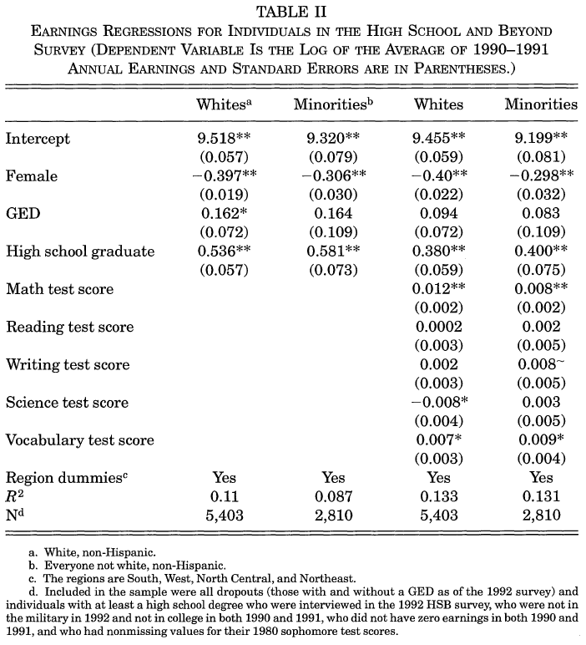
  - In the first regression model (the first column), what is the effect of holding the GED on earnings for whites? (0.5 point) Is this effect statistically significant? (0.5 point)
  - In the third regression model (the third column), after adding controls of test scores, does holding the GED still have an effect on earnings for whites? (0.5 point)
Solution:
According to the first column, holding the GED increases 16.2% of the average 1990-1991 annual earning for whites. This effect is statistically significant at the 10% level as indicated by the single asterisk next to the point estimate.
According to the third column, after adding controls of test scores in the model, holding the GED no longer has an effect on earnings for whites because the point estimate 0.094 is not significantly different from zero (no asterisk).

